Chapter 7, Problem 73.

For the op amp circuit of Fig. 7.138, let R₁ = 10 kΩ, R_{f} = 20 kΩ, C = 20 μF, and v(0) = 1 V. Find v_{o}.

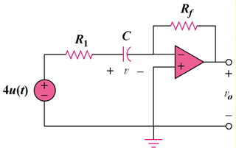

Figure 7.138
For Prob. 7.73.

